**Buffering**

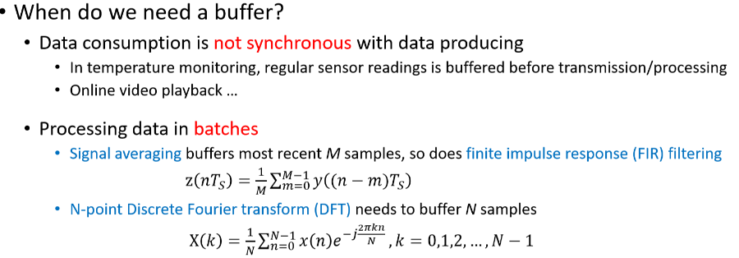Buffer = Region of physical memory for storing data (temporarily)

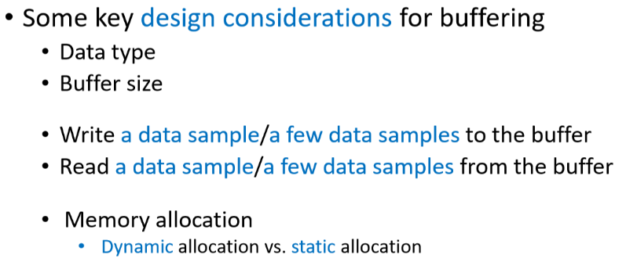

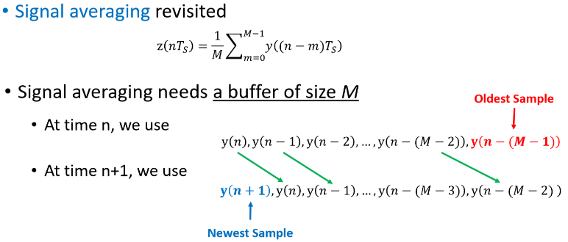

**Circular Buffer**

* Dynamic = latches = no, refresh = yes, (slow)
* 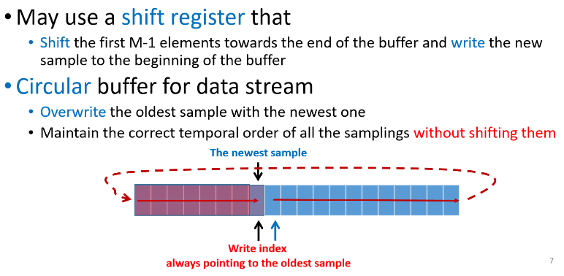Static = latches = yes, refresh = no (fast)
* Using a signal averaging buffer
* We can use a shift register(s).
* Interrupts with this buffer can cause some data samples to get lost

**Double buffer** (use this for data protection)

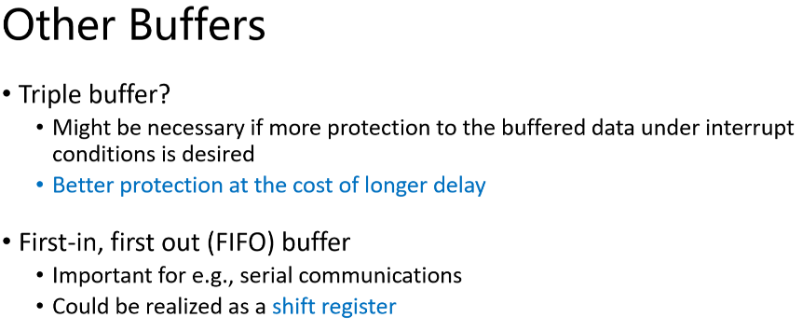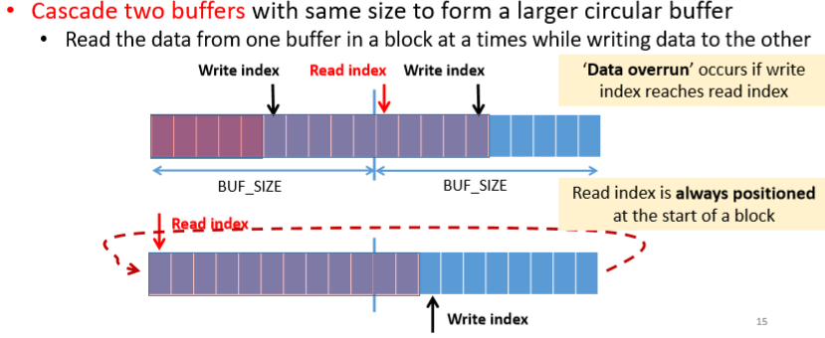Provide protection to buffered contents under interrupt condition(s).